San-Meet
Analysis Model

Submitted to:

Asst. Prof. Ma. Rowena C. Solamo
Faculty Member
Department of Computer Science
College of Engineering
University of the Philippines, Diliman

Submitted by:
Bryce Spencer Batula
Michael John Bayuga
John Theodore Yap

In partial fulfillment of Academic Requirements
for the course
CS 191 Software Engineering I
of the
1st Semester, AY 2015-2016
Revision Control

History Revision:
Revision Date | Person Responsible | Version  Number | Modification
MM/DD/YY | Bryce Spencer Batula  Michael John Bayuga  John Theodore Yap | 1.0 | Initial Document; Version number should match the one found in the footer.

System Name: Meeting Application

Description: [Brief Description of the System in 3-7 sentences.]

Class Diagram:
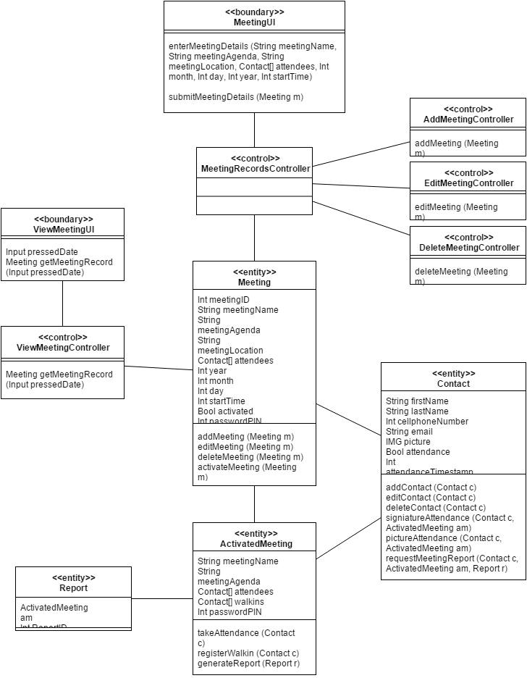
_

Boundary Classes:

Class Name | Description
MeetingUI | Gets the meeting information and sends it
ViewMeetingUI | Views meeting from a specific date

Control Classes:

Class Name | Description
MeetingRecord | Keeps the records of future and past meeting
AddMeetingController | Adds a new meeting on the calendar
EditMeetingController | Edit an existing meeting
DeleteMeetingController | Deletes an existing meeting
ViewMeetingController | Meeting record can be view here

Entity Classes:

Class Name | Description
Meeting | Adds the details for the meeting
Contact | Adds a new contact for the meeting
ActivatedMeeting | The class that gets the meeting attendance. When going back to see other meetings, it will ask the user for the password
Report | Outputs the summary of the meeting (including the attendance, etc.)

